GUANGJI BRIDGE

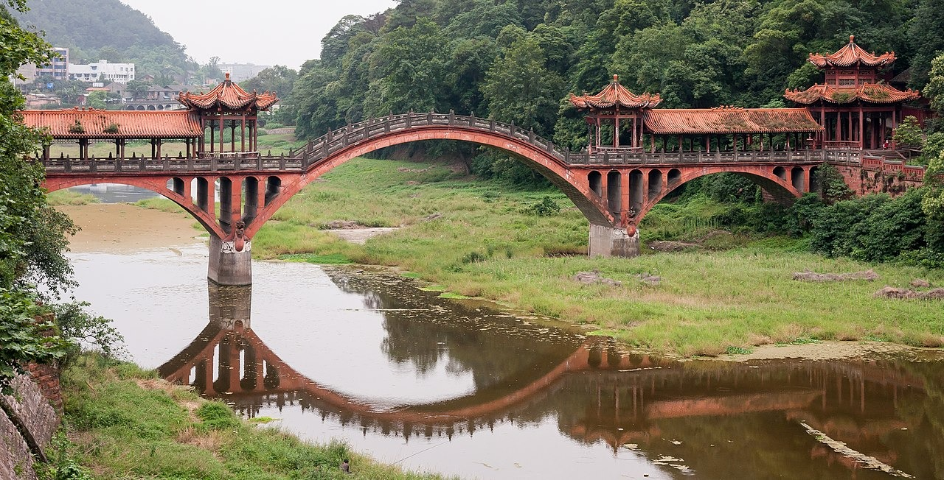
The Guangji Bridge, a magnificent architectural marvel nestled in Chaozhou City, Guangdong Province, China, stands as a testament to the ingenuity and craftsmanship of ancient Chinese engineers. Dating back to the Southern Song Dynasty, approximately in the 12th century, this venerable structure spans gracefully over the Han River, a tributary of the Pearl River. With its distinctive combination of stone arches and beam spans, the Guangji Bridge exemplifies a fusion of functionality and beauty. Its construction, primarily of locally quarried stone meticulously fitted together without mortar, showcases the meticulous attention to detail and engineering prowess of its builders. Stretching an impressive 518 meters in length and featuring 18 spans supported by sturdy stone piers, the bridge seamlessly integrates into the surrounding landscape. Ornate stone carvings and sculptures adorn the bridge, depicting scenes from Chinese mythology and history, adding to its allure and cultural significance. Throughout centuries of history, the Guangji Bridge has withstood the test of time, witnessing the ebb and flow of dynasties, trade routes, and cultural exchanges. Today, it continues to serve as both a vital transportation artery and a cherished symbol of China's rich cultural heritage. Visitors flock from far and wide to marvel at its ancient architecture, stroll across its venerable spans, and immerse themselves in the history and beauty of Chaozhou City's old town district. In essence, the Guangji Bridge stands not only as a physical link across the Han River but also as a bridge spanning The Guangji Bridge, affectionately known as the "Bridge of Nine Ghosts" due to its nine exquisite pavilions, beckons travelers on a journey through time. Its graceful arches and sturdy stone piers, us that even as the world around us evolves, some treasures endure, eternally bridging the gap between past, present, and future. centuries, connecting past and present, and inspiring awe and admiration in all who behold its grandeur.

